PCTURES OF JOINT INVESTIGATION VISIT TO OANDO ENERGY RESOURCES LIMITED FACILITY AT 6” OGBOINBIRI/TEBIDABA PIPELINE, TEBIDABA, SILGA BAYELSA STATE ON 2ND OCTOBER, 2024.
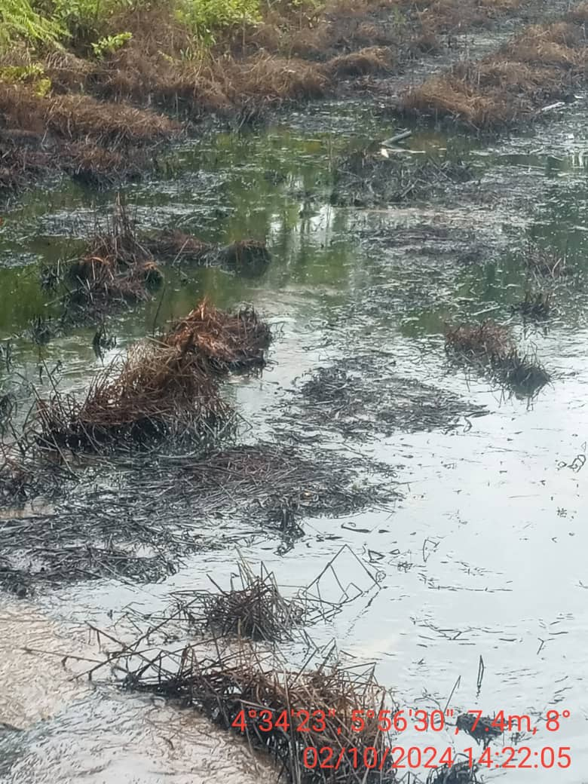
FIG. 1: THE STATE OF THE ENVIRONMENT AS AT THE TIME OF JIV.
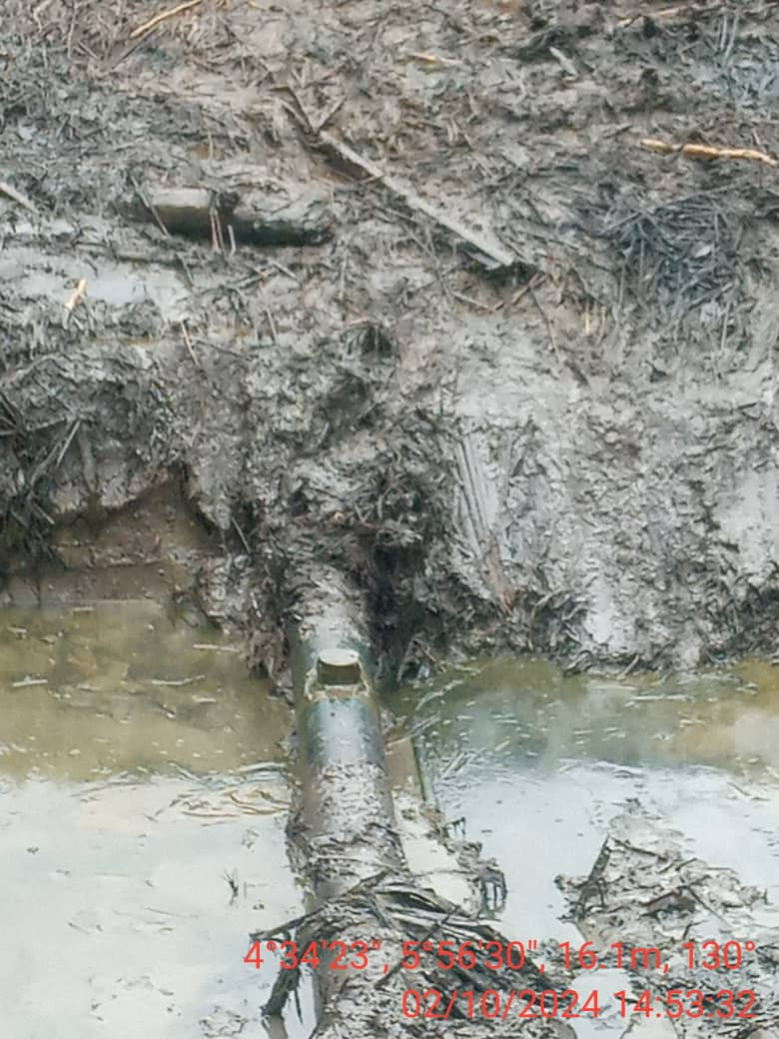
FIG. 2: 3” VALVE INSTALLED AT 12 O’ CLOCK POSITION FOR POSSIBLE CRUDE OIL THEFT BY VANDALS.

